Plymouth City Council Net Zero Action Plan 2025-2028

What is the Net Zero Action Plan?
The Net Zero Action Plan (NZAP) is a three-year delivery plan, setting out the City Council’s proposals to reduce its greenhouse gas emissions. It responds to the Net Zero Plymouth challenge set out in the Climate Connections Plymouth website and explains how the City Council will aim to play its part in delivering the Plymouth Plan’s policy aim. The NZAP is reviewed each year to ensure it remains in step with new developments in the council’s activities. This NZAP covers the period 2025-2028 and supersedes the NZAP 2024-2027. The full list of NZAP actions for 2025-2028 is available in annex I (page 12). We continue to pursue commitments made for the period 2024-2027, but these have been reviewed to account for initiatives that have become part of our usual practices and will no longer be reported (see annex II, page 21) or changes in the scope or timescales of some of our commitments.

Why do we need an action plan?
On 18 March 2019, at a meeting of the City Council, councillors unanimously voted to declare a Climate Emergency, making a pledge to make Plymouth carbon neutral by 2030. This spirit of collaboration has continued through cross-party working on the climate emergency ever since.
This pledge exceeds the climate objectives of the UK, which are to achieve net zero by 2050, recognising the need for the 2020s to be a decade of urgent and accelerated action.
The City Council alone cannot ensure that Plymouth achieves net zero. For that to happen, every individual and organisation needs to play its part. However, it can do all in its power to make sure that it addresses its own emissions. This is why it is so important for the City Council to put in place its own delivery plan for net zero.

Where are we now?
The table shows our measured emissions since 2019. These cover what are known as Scope 1 and 2 emissions. The NZAP will aim to accelerate the reduction of these emissions so that the Council is a net zero organisation by 2030 with regards to its scope 1 and 2 emissions.
We have committed to continually improve our understanding of our corporate greenhouse gas (GHG) emissions. As part of this continuous improvement, in 2023, we changed the way we collect data and calculate our GHG emissions. After a review of our data collection and reporting, we asked the Centre for Energy and the Environment at the University of Exeter to complete the reporting for us.
We are now reporting at the end of each financial year, which run from 1st April to 31st March, rather than at the end of calendar years. The information we need to calculate our emissions becomes available to us after we close our accounts. This method simplifies the process of obtaining accurate data. We also now include a calculation of our Scope 3 emissions. This new methodology means that our new emissions are not comparable like-for-like with previous emissions reporting.
In Table A below, we present data collected using the previous methodology between 2019 and 2022. Table B presents data collected using the new methodology in 2022/23 and 2023/24.

Table A - Plymouth City Council GHG Emissions (in tCO₂e) between 2019 and 2022

Sector | 2019 | 2020 | 2021 | 2022 | Change from 2019 baseline
Council buildings | 4,051 | 3,306 | 3,815 | 3,198 | -21.1%
Vehicles / fleet / transport / equipment | 1,545 | 1,744 | 1,584 | 1,691 | 9.4%
Roads and street furniture, including lighting and traffic lights | 2,002 | 1,807 | 1,390 | 1,266 | -29.0%
Staff and councillor travel / travel at work | 326 | 218 | 218 | 157 | -51.8%
Total (Tonnes of CO2e) | 7,924 | 7,075 | 7,007 | 6,312 | -18.1%

Table B - Plymouth City Council GHG Emissions (in tCO₂e) by theme between 2022/23 and 2023/24 (all scopes)
Theme | 2022/23 | 2023/24 | Change from 2022/23 baseline
Transport - Employee commuting | 802 | 792 | î | -1.25%
Transport - School transport | 548 | 615 | ì | 12.23%
Transport - Business travel | 220 | 202 | î | -8.18%
Transport – Fleet | 2,023 | 2,083 | ì | 2.97%
Street signaling | 234 | 250 | ì | 6.84%
Street lighting | 1,478 | 1,567 | ì | 6.02%
Buildings – Waste | 317 | 248 | î | -21.77%
Buildings - Working from home | 558 | 547 | î | -1.97%
Buildings - Corporate estate | 5,301 | 4,897 | î | -7.62%
Total emissions within the Council’s direct control | 11,481 | 11,201 | è | -0.02%
Purchased services and works | 31,678 | 32,251 | ì | 1.81%
Purchased goods | 3,924 | 3,421 | î | -12.82%
Total emissions including purchasing | 47,083 | 46,873 | î | -0.45%

Table C - Plymouth City Council GHG Emissions (in tCO₂e) by scope between 2022/23 and 2023/24

Scope | 2022/2023 | 2023/2024 | Change from 2022/23 baseline
Scope 1 | 3,504 | 3,231 | î | -7.79%
Scope 2 | 3,566 | 3,692 | ì | 3.35%
Total Scope 1 and 2 | 7,070 | 6,923 | î | -2.08%
Scope 3 | 40,017 | 39,949 | è | -0.17%
Offset carbon | 0 | 0 | è | 0
Total | 47,087 | 46,872 | î | -0.45%

We keep this information under constant review.
Data relating to city wide emissions is available in the https://climateconnectionsplymouth.co.uk/wp-content/uploads/2023/07/Plymouth-Greenhouse-Gas-Monitoring-Report-2022-Accessible.pdf

What have we already delivered from our previous plans?
The City Council acknowledges that achieving net zero, both as an organisation and as a city is a journey. It cannot be achieved overnight. However, since our first action plans in 2019 we have made significant steps on that journey.
The following are examples of actions we have already taken to drive down emissions across our organisation and in the city.
Beryl e-bikes
- We expanded the e-bike network to 115 locations and 510 e-bikes across Plymouth.
- Beryl bikes reached 26,000 registered users, who collectively took nearly 200,000 e-bike journeys.
- We gave free access to e-bikes to 112 people through the Beryl-PCC social prescribing offer, with users riding 22 times on average.
Electric vehicle charge points
- We have constructed 40 locations for rapid electric charging points station across Plymouth.
- We were awarded £2.4 million of capital funding and £409,000 of revenue funding to roll out electric vehicle charge points for people without off-street parking.
- We launched the Electric Vehicle Infrastructure Strategy for Plymouth.

Car Club
- We appointed Co Wheels to run an electric car club in Plymouth.

District Heating Network
- We were selected by central government as one of 17 cities in the Advanced Zoning Programme, which has provided us with £800,000 of funding for design, procurement, and grant application for the first phase of a heat network in the city. Plymouth is one of 6 towns and cities nationally to have made the shortlist to form the first zones, which will channel further resources and opportunities to our city.

Decarbonisation of the Council’s estate
- We completed work on air source heat pumps in eight City Council buildings.
- We obtained £108,000 of Salix funding to decarbonise Harewood House.
- We received £21,000 from the Southwest Net Zero Hub to draw together technical and business case to improve energy efficiency of buildings at Mount Edgcumbe.

Retrofitting homes
- 60 off-gas homes in Plymouth are being retrofitted with energy efficiency improvements, solar panels, and heat pumps through the government’s HUG2 programme which has provided £1.1 million of funding.
- We awarded a contract to Independence CIC to run a Dynamic Purchasing System that will help to steer energy efficiency retrofit work towards local suppliers.
- We completed Phase 1 of the Social Homes Decarbonisation Fund, which retrofitted 82 social homes with Plymouth Community Homes and LiveWest using £967,000 of grant funding.
- We completed Phase 2 of the Social Homes Decarbonisation Fund, retrofitting 125 social homes with LiveWest, using £1.4 million of grant funding.

Engagement
- We involved 2,786 individuals through our programme of net zero events.
- We reached over 31,000 through our social channels, established 1,035 followers (between January and November 2024).
- We launched Climate Mingle, a regular networking event sharing stories from those leading the way across the city.
- We crowned 5 Local Climate Legends celebrating heroes going the extra mile, with films sharing the stories of the winners from business, youth, community, and schools.
- We worked with 40 organisations and community groups across the city to deliver the Big Green Trail collaborating with organisations across the city and involving 754 beryl e-bike rides on the day, with 80 first time riders.
- 111 organisations signed up to the Climate Connections ‘Who’s Who’ directory for organisations to share their net zero commitments and action plans.
- The Plymouth Net Zero Partnership continues to engage with key stakeholders across the city.

The monitoring reports for our previous action plans can be found by following this link:

Previous climate and corporate action plans | PLYMOUTH.GOV.UK

What does the NZAP cover?
The NZAP covers two fundamental areas:
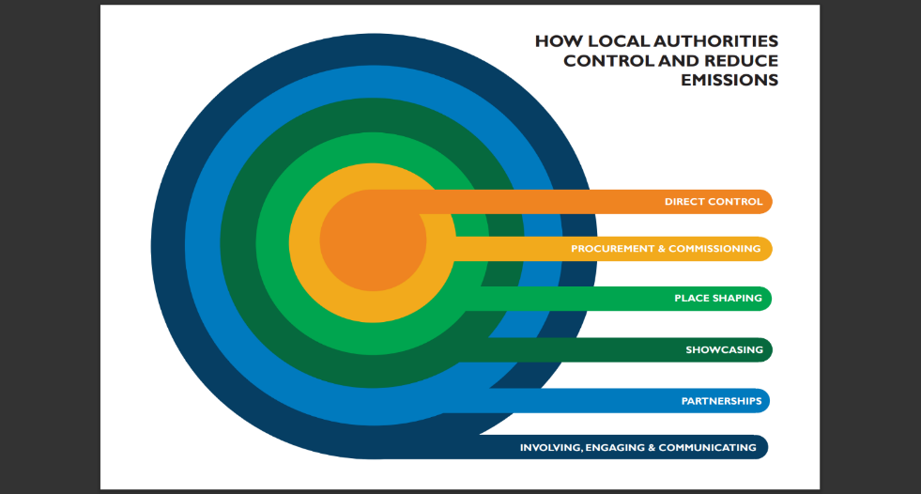
First, it includes action commitments to reduce emissions from the facilities we own and the services we deliver. Our own operations generated 11,201 tonnes CO₂e in 2023/24, approximately 1% of the city’s emissions.
Second, it includes commitments about how we will use our powers to help the city as a whole move towards net zero. According to the Climate Change Committee’s ‘Local Authorities and the Sixth Carbon Budget’, councils influence about 30% of emissions in their locality. Ways in which councils can do this are shown in this diagram:

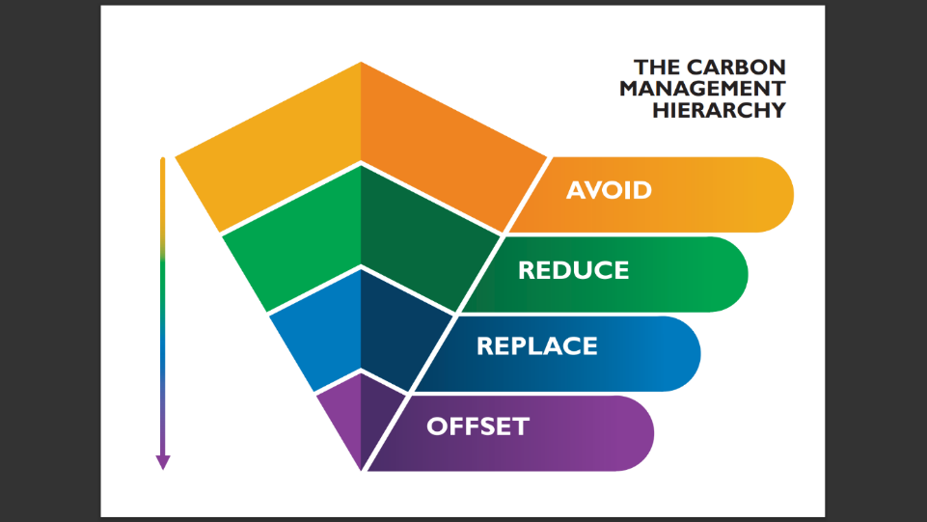
What is our overall approach?
The NZAP has been guided by what is known as the Carbon Management Hierarchy (CMH). This aims to give focus first to actions that avoid emissions in the first place, followed by those that reduce emissions. Lower in the hierarchy are actions to replace high carbon energy sources with low carbon alternatives, and offsetting is seen as the last resort for any residual emissions.

In addition, we are working to make available locally based, high-integrity carbon offsets that remove carbon through natural solutions. This includes the following projects:
- Establishing a delivery mechanism for local offsetting through Ocean City Nature.
- Delivering Plymouth and South Devon Community Forest Woodland Carbon Credits project.
- Delivering the Council’s Plan for Trees, which will also improve the city’s resilience to the effects of climate change.

What are our key priorities for net zero?

Corporate Priorities | Citywide priorities
Rationalise and decarbonise our fleet of vehicles. | Support walking, cycling and public transport.
Invest in renewables and energy efficiency measures across our corporate estate and infrastructure. | Improve electric vehicle infrastructure.
 | Implement a strategic heat network.
Change our working practices to reduce emissions from business travel, purchasing and service delivery. | Continue to deliver housing retrofit schemes that support households in achieving greater energy efficiency and renewable energy generation.
 | Engage all residents, organisations and stakeholders in the Net Zero mission.
The Plymouth Climate Connections website identifies the key priorities for the city. The NZAP aligns the Council’s activities with these priorities. Action commitments are grouped under three themes:
- Transport,
- Buildings, heat, and power,
- Behaviour change.

Transport
According to our June 2024 Corporate Emissions Monitoring Report, transport accounted for nearly 33% of the carbon emissions within our direct control in 2023/24.
The decarbonisation of our fleet of small vehicles is already underway. Transitioning our fleet of larger vehicles presents technological, financial, and organizational challenges that require considerable forward planning.
According to the Plymouth Greenhouse Gas Report 2024, transport accounted for 34% of our city’s emissions in 2022. This proportion has increased (from 28% in 2021) as other sectors are decarbonising faster. Tackling city transport emissions will require a shift in the uptake of walking, cycling and public transport, as well as measures to replace petrol combustion vehicles with electric vehicles. The NZAP outlines policies and infrastructure proposals that support members of the public with making this change. Go to Climate Connections Plymouth website for a summary of the city-wide picture on transport emissions.
Measures set out in the NZAP that have the greatest potential to reduce emissions substantially include:
- Implementing the Electric Vehicle Charging Infrastructure Strategy for the City (T4).
- Implementing the Plymouth Zero Emission Bus Regional Area 2 Fund project in full delivering 59 electric double decker buses and associated charging infrastructure (T5).

Buildings, Power, and Heat
In 2023/24, 60% of our corporate emissions were generated through electricity and gas use in council buildings and to power street furniture, including lighting and traffic lights.
Our actions will focus on the corporate buildings we use to deliver our services and the built infrastructure we maintain. We will take action to increase to its maximum the energy efficiency of our existing and future estate and to shift our energy demand to renewable energy. This also includes actions to minimise fugitive emissions and water consumption; actions to minimise carbon emissions from our repair and maintenance activities and actions to minimise carbon emissions from any new buildings we commission.
In 2022, about 26% of the city’s greenhouse gas emissions were attributable to heating, and 17% of the emissions were associated with generating electricity for our buildings. The transition to net zero involves a shift towards renewable energy for heating (heat pumps and heat networks) and rapid large-scale insulation of private and commercial buildings across the city. We will act in support of the decarbonisation of power and heat in the city through our planning functions.
Go to Climate Connections Plymouth website for a summary of the city-wide picture on buildings, power, and heat emissions.

Measures set out in the NZAP that have the greatest potential to reduce building emissions substantially include:
- Supporting 700 households with energy efficiency and renewable energy measures through the Warm Homes Local Grant (BHP9).
- Commencing the first phase of the £400 million heat network for Plymouth supported by the Government’s Advanced Zoning Programme (BHP10).

Behaviour Change
Activities to promote positive working practices to minimize emissions associated with our everyday activities. These actions will support reductions in the transport, energy, consumption, and waste sector.
According to the Sixth Carbon Budget, while 41% of emission reduction required to achieve net zero will be purely technological, the remaining 59% will include societal behavioural changes.

What are the wider benefits from the Council taking climate action?
Tackling climate change is compatible with delivering many of the City Council’s priorities, whilst also helping deliver savings through being more efficient in our operations and reducing our energy consumption.
The investments have led to income generation from the sale of renewable energy and a reduction in the City Council’s energy bills, providing an ongoing an annual benefit to the City Council in the region of £500,000.
Many of the activities detailed in this plan intend to bring about multiple co-benefits, so we do not have to make a choice between the climate and other critical issues such as economic inequality or health and wellbeing. For example, through climate action, we can improve air quality and create places that have a positive impact on our wellbeing. By promoting active travel, we can bring about some positive health benefits. The creation of green jobs provides opportunities for our city’s future prosperity. Actions to cut down our energy consumption and adopt renewable energy produced locally will help bring down the cost of keeping our homes warm.

What other initiatives and programmes will the NZAP complement?

The focus of the NZAP is on how the Council will reduce carbon emissions. However, the Council is also committed to other initiatives and programmes to deal with the consequences of climate change and to improve health, wellbeing and environmental quality of the city overall. Some examples are given below:
- The Net Zero Action Plan is the council’s contribution to the efforts of the Plymouth Net Zero Partnership. It complements the initiatives promoted on the Climate Connections website.
- Through our Climate Emergency Planning Statement, all new developments must consider the impacts of climate change, and include measures such as delivering at least 10 per cent biodiversity net gain, sustainable drainage, and soil protection.
- Through the Local Cycling and Walking Infrastructure Plan, and supporting programmes, we identify cycling and walking improvements needed to increase levels of active travel.
- Through our City Change Fund, we support local projects that help tackle climate change and deliver a city that is more resilient to its effects.
- Through Thrive Plymouth, we work to improve health and wellbeing and reduce health inequalities, including promoting healthy lifestyles. Associated behavioural changes not only complement the NZAP’s aim to reduce emissions (for example, through encouraging active travel such as walking and cycling), but also create a more resilient population to anticipate impacts of climate change.
- Through our Cost of Living Taskforce, we are working with partners across the city to support families and individuals to access support in making their homes more energy efficient, in reducing their use of energy, and in helping to manage finances when they struggling to pay gas and electricity bills.
- The Plymouth Sound National Marine Park will encourage greater prosperity and engagement with our marine environment. Building on our current work and existing structures, it will support a new approach to how we value and work in harmony with the natural environment to deliver the greatest benefit for all. Our vision is for a National Marine Park that supports thriving businesses, connected communities and inspired visitors.
- The Plymouth and South Devon Community Forest is an ambitious project that will see hundreds of new trees planted across the city.
- The Plymouth and South Devon Freeport is collaborating with partners to deliver Net Zero emissions target significantly ahead of 2050. It will monitor emissions and actively drive Decarbonisation with Freeport landlords and tenants. The Freeport designation and seed capital function as a catalyst in the delivery of a 10MW Green Hydrogen Electrolyser at Langage, a Pedestrian and Cycle Bridge across A38 connecting the 2 tax sites at Langage and Sherford and the Innovation Centre in South Yard. The significant opportunities in Net Zero Innovations with partners and business are key to achieving Net Zero and positioning Plymouth in growth sectors, like the supply and maintenance of Floating Offshore Wind in the Celtic Sea.
- Working in partnership with the Devon, Cornwall and Isles of Scilly Local Resilience Forum, helping deliver the Devon, Cornwall and Isles of Scilly Adaptation Plan Adaptation Plan – Devon Climate Emergency addressing the impacts of climate change. We will also collaborate with local partners on a more detailed City Adaptation Plan and Climate Change risk assessment to help the Council prepare for and manage the impacts of climate change on the services it provides and on city’s wildlife and natural environment.
This connectivity between wider plans and the Council’s delivery programmes and plans for responding to the climate emergency is shown diagrammatically below.

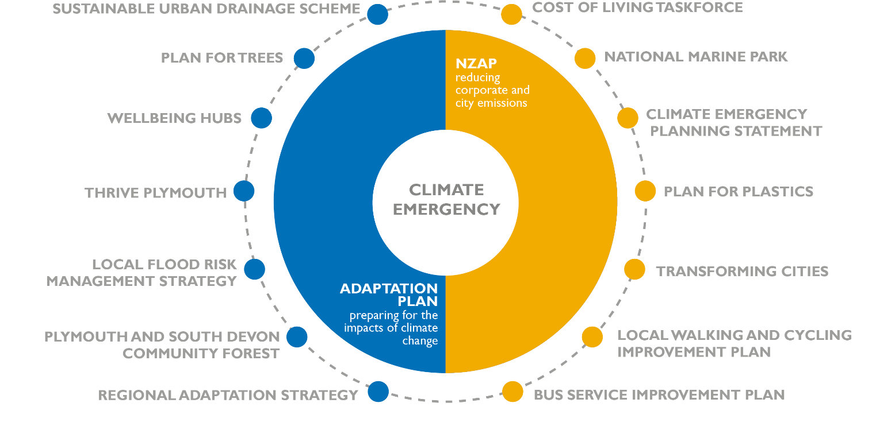
The diagram is illustrative only and is not intended to be comprehensive.

How will we ensure that climate action is fair and leaves no one behind?
Taking climate action by reducing emissions to zero as rapidly as possible and putting in place plans to mitigate the worst impacts of climate change is the best way to bring about positive outcomes for all, including current and future generations, irrespective of age, race, disability, gender, sexual orientation or religion.
We need commitment from everyone, but we understand that we are not all equally able to act. Our role is also to ensure, whenever we can, that our city’s transition to net zero is just and leaves no one behind.
To do so, we will appeal to government to ensure that the necessary resources are distributed to allow all people to make the transition to a more sustainable way of life. For example, we will continue to seek government grants for home energy efficiency that can be redistributed to those most in need. We will be promoting green skills, training and jobs, to ensure there are good employment opportunities for all. We will continue to support transport solutions to widen access to mobility, mindful of the needs of vulnerable groups.
Our engagement activities will follow the principles set out in paragraph 2.1 of the City Council’s Statement of Community Involvement, and will promote equality and diversity.
In the delivery of all our actions, we will comply with the requirements of the Equality Act 2010.

How will we deliver the NZAP?
As a three-year delivery plan, not every measure identified in the NZAP is fully funded from day one. Some of the measures proposed are fully or partially funded; for example, because they can be delivered with existing staff resources or have grants or other funding already in place. Others will require further work to explore delivery options and funding opportunities. However, given the scale and urgency of the challenge, it is important that the plan is ambitious whilst also being within the bounds of realism, acknowledging the funding limits as well as the policy differences between the Council’s net zero target and that of national government. That is the balance we have sought to meet in putting this plan together.

Notes to accompany the NZAP.
The Carbon Management Hierarchy (CMH) is a prioritisation model in 4 steps (Avoid, Reduce, Replace and Offset). This model gives focus first to actions that avoid emissions in the first place, followed by those that reduce emissions. Lower in the hierarchy are actions to replace high carbon energy sources with low carbon alternatives, and offsetting is seen as the last resort or any residual emissions.
Indicators of Impact and Cost are presented for each strategic commitment to help guide and prioritize activity. Both are presented in terms of High/Medium or Low.
Impact – This is an indicator of the potential impact on emissions from the actions taken in the period. For corporate actions, the context is our known corporate emissions. For citywide influencing actions, the context is the city’s emissions.
High impact actions, once completed in full, are likely to make a significant impact on corporate carbon emissions. Low-impact actions may only marginally impact carbon emissions in this period, but may present other advantages, such as facilitating emission reductions elsewhere.
We have further work to do on getting a complete understanding of all our corporate emissions, and this is reflected in the NZAP. This work will enable us to be more specific about our impact measures in future years.

Cost - This is an indicator of potential financial outlay (capital or revenue) needed to deliver the actin commitment. It is based on assumptions when specific data is not available.
High-cost activities are those that are likely to require significant outlay in relation to other areas of spend, Low-cost activities are expected to be funded with normal service budget.

Key terminology:
Net Zero – An approach to minimise greenhouse gas emissions to as close to zero as possible, and then put in place offsetting measures to cancel out emissions that cannot be avoided.
Carbon Neutrality – Carbon neutrality is the same approach, and the phrase is often used interchangeably, but the expression may be misleading as focusing only on carbon, one of four greenhouse gases.
Scopes 1, 2 and 3 – are defined by an internationally accepted methodology for accounting for greenhouse gas emissions, the Greenhouse Gas Protocol. Scope 1 emissions relate to the direct burning of fossil fuels by an organisation, for example fuel for transport or gas for heating, Scope 2 emissions relate to emissions from purchased or acquired electricity, steam, heat, and cooling. Scope 3 emissions relate to all other activities where emissions are generated by a third party on behalf of an organisation, for example across our supply chain.
GHG – Greenhouse gases, including carbon dioxide, methane, nitrous oxide and fluorinated gases.
Offsetting – a carbon offset is a financial product serving to compensate for carbon emissions by investing in a project that will reduce future emissions or capture existing CO₂ from the atmosphere.

References:
- Plymouth City Council Carbon emissions monitoring report, June 2023
- Plymouth City Council Carbon emissions monitoring report, June 2022
- Mitchell, T.A. and Norton, A.D.S. (2023) ‘Plymouth Greenhouse Gas Reporting and Monitoring 2023’, University of Exeter Centre for Energy and the Environment, July 2023, Available at: What does this mean for Plymouth? - Climate Connections Plymouth
- Matrix Evans, L. (2020) ‘Local Authorities and the Sixth Carbon Budget’, an independent report for the Climate Change Committee.
- Greenhouse Gas Protocol | (ghgprotocol.org)

ANNEX ONE: Net Zero Action Plan 2025-2028

Theme | Ref. | Goals for the period 2025/28 | Strategic Commitment | Actions | Year | Strategic Leader
Buildings, Heat and Power | BHP1 | Reduction in carbon emissions from our estate by 20% between 2025 and 2028 | Improve the thermal performance and energy efficiency of all remaining corporate workspaces and end the use of fossil fuel heating. | Continue the programme of energy audits on council property and create a strategic plan for minimising energy waste. | 2025/26 | Interim Chief Operating Officer
 |  |  |  | Pursue funding opportunities to implement smart controls for heating and deliver fabric-first heat retention measures across our corporate estate. | 2025-28 | Interim Chief Operating Officer
 |  |  |  | Replace gas boilers in city council buildings through, for example, the installation of heat pumps or connection to low carbon heat networks. | 2025-28 | Interim Chief Operating Officer
 |  |  |  | Produce a costed plan for retrofitting the council’s estate, prioritising invest-to-save measures. | 2025-27 | Interim Chief Operating Officer
 |  |  |  | Explore the viability of hosting a data centre at the Life Centre swimming pool to reduce gas consumption. | 2025-28 | Director of Public Health
Buildings, Heat and Power | BHP3 | Produce the equivalent of 70% of our 2023 electricity needs by 2026 using solar energy | Shift our electricity consumption to renewable energy | Deliver a solar farm at Chelson Meadow. | 2025-27 | Interim Strategic Director for Growth
 |  |  |  | Maximise the opportunities for installing solar panels on more of our own assets and pursue funding opportunities to do so wherever possible. | 2025-28 | Interim Strategic Director for Growth
 |  |  |  | Purchase renewable electricity from the proposed Chelson Meadow solar farm for a proportion of our activities and explore the options to purchase renewable electricity for the remainder. | 2026/27 | Interim Chief Operating Officer
Buildings, Heat and Power | BHP4 | Achieve a 40% reduction in energy consumption for street lighting by 2026 (based on 2021 energy consumption figures) | Reduce the energy consumption needed to operate the public highway | Implement a new system of improved control and management of street lighting where permissible. | 2025/26 | Interim Strategic Director for Growth
 |  |  |  | Continue the programme of replacement of all illuminated traffic island bollards to more economical alternatives. | 2025-28 | Interim Strategic Director for Growth
Buildings, Heat and Power | BHP6 | Policy to guide our corporate construction activity is in place by end of 2025/26 | Strive to implement the highest possible standard of sustainability in the development of new council construction projects. | Develop a policy to guide how all corporate construction activity (buildings and infrastructure) is commissioned and delivered. | 2025/26 | Interim Strategic Director for Growth
 |  |  |  | Continue to deliver the Eco-homes Programme and showcase the resulting low carbon housing. | 2025-28 | Interim Strategic Director for Growth
Buildings, Heat and Power | BHP7 | Planning policy framework for Net Zero embedded into next local plan by 2027 | Provide a policy framework that supports the decarbonisation of land use and buildings across the city. | Ensure that the next local plan responds to the city’s net zero ambition and the need for Plymouth to be a climate resilient city. | 2025-28 | Interim Strategic Director for Growth
Buildings, Heat and Power | BHP8 | Significant progress towards ensuring that all the City Council's commercial properties have an Energy Performance Certificate of C or above by 2026, in support of national target to achieve this outcome by April 2027. | Facilitate a reduction in emissions from our commercial estate | Continue the ongoing review of Energy Performance Certificates across the commercial estate. Begin feasibility work to reach a minimum C rating. Work positively with our commercial tenants to support and where possible facilitate improvements to energy efficiency of buildings, including signposting them to any grant funding opportunities. | 2025-28 | Interim Strategic Director for Growth
Buildings, Heat and Power | BHP9 | 700 households supported between 2025-2028 | Continue to develop and deliver schemes that support households in achieving greater energy efficiency and renewable energy generation, ensuring that poorer communities are not left behind, in partnership with Plymouth Energy Community and other partners. | Support 700 households with energy efficiency and renewable energy measures through the Warm Homes Local Grant. | 2025-28 | Interim Strategic Director for Growth
Buildings, Heat and Power | BHP10 | 7,500 MWh/a of heat supplied by new low carbon heat networks in Plymouth by end 2027/28 | Support the development of a low carbon energy generation and distribution infrastructure that will meet our future energy needs. | Commence the first phase of the £400 million heat network for Plymouth supported by the Government’s Advanced Zoning Programme. | 2025-28 | Interim Strategic Director for Growth
 |  |  |  | Deliver enabling works towards creating heat network clusters at the Guildhall and Civic Centre, supplying the Theatre Royal, Combined Courts and Civic Centre Redevelopment with low carbon heat. | 2025-27 | Interim Strategic Director for Growth
 |  |  |  | Work with our partners in the Devon Climate Emergency to develop a Local Area Energy Plan. | 2025-27 | Interim Strategic Director for Growth
 |  |  |  | Support the delivery of a 10MW Green Hydrogen Generation plant at Langage. | 2027/28 | Interim Strategic Director for Growth
Transport | T1 | Work towards a reduction of 7% in our business travel by 2030. | Deliver corporate policies and initiatives that minimise travel and encourage the adoption of active travel and low carbon alternatives. | Continue to deliver schemes to support Council staff and Councillors to minimise travel where possible and to adopt low carbon business travel and travel to work in line with the Go Green Travel Plan. | 2025-27 | Service Director for Human Resources and Organisational Development
Transport | T3 | Replace 30% of our fleet by electric vehicles by end of 2026 (70 out of 220 vehicles), including 100% of our small fleet. | Implement a vehicle decarbonisation programme. | Continue the fleet rationalisation programme and the replacement of our small vans and cars by zero carbon vehicles. | 2025-28 | Interim Strategic Director for Growth
 |  |  |  | Pursue funding opportunities to create charging substations to meet the increasing energy needs of the Council fleet and to deliver trials of zero emission specialist vehicles within the Council fleet. | 2025-28 | Interim Strategic Director for Growth
 |  |  |  | Commission a study on pathways to decarbonise the city council’s fleet of large specialist vehicles, with a view to phasing out the purchasing of new diesel vehicles and replacing the rest of the Council fleet with zero emission vehicles in the period between 2027 and 2030. | 2025/26 | Interim Strategic Director for Growth
Transport | T4 | Progress multiple initiatives to incentivise sustainable transport. | Provide local policies and initiatives that facilitate the decarbonisation of the transport system. | Explore options, feasibility, potential role and benefits of emissions-based vehicle charging tariffs in both incentivising sustainable transport choices and in supporting sustainable transport projects. | 2025/26 | Interim Strategic Director for Growth
 |  |  |  | Submit an expression of interest for participation in the Department of Transport's e-scooter trial scheme. | 2025/26 | Interim Strategic Director for Growth
Transport | T5 | Contribute towards the achievement of the Enhanced Partnership Bus Service Improvement Plan bus patronage targets (2030 Bus Service Improvement Plan (BSIP) target (23,013,275) and 2034 BSIP target (26,073,937).  Achieve a target of 30,000 registered beryl bike users as a proxy for regular cycling in the city.  Install public Electric Vehicle charge points for use in 200 parking bays each year in 2026, 2027 and 2028.  Delivery of the final 1.3 miles of improved cycling and walking routes by 2026.  10 new or improved road crossing points by 2026. | Contribute to providing public infrastructure needed to meet the city's low carbon transport needs. | Implement the Electric Vehicle Charging Infrastructure Strategy for the City, including establishing charging hubs at key destinations, on-street provision, and considering electric vehicle users in parking policy and infrastructure projects. | 2025-28 (as part of a 10-year strategy to 2034) | Interim Strategic Director for Growth
 |  |  |  | Deliver the programme of improved cycling and walking routes, and improvement of road crossing points. | 2025/26 | Interim Strategic Director for Growth
 |  |  |  | Work with the car club provider to support the expansion of the pool of electric vehicles available to the public, with the aim of doubling the number of vehicles available between 2025 and 2026. | 2025/26 | Interim Strategic Director for Growth
 |  |  |  | Implement the Plymouth Zero Emission Bus Regional Area 2 Fund project in full delivering 59 electric double decker buses and associated charging infrastructure. | 2025/26 | Interim Strategic Director for Growth
 |  |  |  | Implement bus corridor improvements, smart signal technology and the reallocation of road space to prioritise buses. | 2025/28 | Interim Strategic Director for Growth
Transport | T6 | Goals set out in the Plymouth Plan | Co-produce decarbonisation plans and initiatives with partners from across the transport system. | Work with regional (Peninsula Transport Strategic Transport Board) and national (Department for Transport-backed Coral programme) partners to explore opportunities for the widespread implementation of integrated ticketing systems on buses. | 2025/28 | Interim Strategic Director for Growth
Behaviour Change | BC1 | Provide a tailored programme of climate change training to 25% of our staff by end of 2026, including offering training to all members and senior managers. | Encourage our staff and members to adopt low carbon behaviours. | Deliver a comprehensive employee engagement programme on climate change, mitigation and adaptation. | 2025-28 | Interim Strategic Director for Growth
Behaviour Change | BC2 | Achieve at least 150 members in the Who's Who section of Climate Connections by end of 2025.  Deliver year on year increase in the number of users engaging with the Climate Connections website.  Work towards the Plymouth Plan target of 65% recycling rate by 2034, with a goal to achieve 53% by 2030. | Develop and deliver an inclusive programme of engagement with the community in collaboration with the Plymouth Net Zero Partnership. | Deliver a Plymouth Net Zero engagement plan in collaboration with the Plymouth Net Zero Partnership (PNZP) and facilitate PNZP Engagement working group. | 2025/26 | Interim Strategic Director for Growth
 |  |  |  | Collaborate, as part of the Food Plymouth Partnership and Network, on improving access to low carbon food choices and work towards achieving the Sustainable Food Places Gold award. | 2025-27 | Director of Public Health
 |  |  |  | Recruit recycling officers to engage with communities to maximise opportunities for increasing recycling levels and compliance with the city council’s waste collection scheme. | 2025-28 | Interim Strategic Director for Growth
 |  |  |  | Deliver a weekly kerbside food waste collection service to Plymouth households in line with Government legislation and guidance. | 2026/27 | Interim Strategic Director for Growth
 |  |  |  | Pursue all funding opportunities to allow the continued provision of the Plymotion behaviour change programme. | 2025/26 | Interim Strategic Director for Growth
Behaviour Change | BC3 | Net Zero action plan identified for top 50 business relationships and supported businesses by 2026  Recommendations from the Green Skills Action Plan are implemented by 2026 | Provide support for transition to a future net zero economy driving investment, increasing knowledge, skills and local capacity in the business community. | Deliver the plan for the city's economic transition to a low carbon economy as part of the overall economic development plan, with the Growth Board taking ownership of the agenda, and continue to identify funding to establish further net zero support for the city’s businesses. | 2025-27 | Interim Strategic Director for Growth
 |  |  |  | Support the delivery of the UK’s first end-to-end commercial waste recycling plant for electric vehicle batteries in Plymouth. | 2025/26 | Interim Strategic Director for Growth
Behaviour Change | BC4 | Net Zero Route Map endorsed by Council and strategic partners by 2027 | Support effective city and regional governance and action on the climate emergency. | Develop a citywide Net Zero Route Map with clear milestones, acting as support for the Plymouth Net Zero Partnership. | 2025/26 | Interim Strategic Director for Growth

ANNEX TWO: Climate actions now embedded into usual business practices

Our annual action plans are allowing us to chart a course to a more sustainable organisational culture. The commitments we made in previous iterations of the Net Zero Action Plan are bearing fruit and our working practices are evolving. The following actions in the Net Zero Action Plan 2024/27 are now embedded within the Council’s usual business practices. To improve the legibility of the plan and minimise its administration, we will no longer publish progress reports on these ongoing activities. The last progress report for each of these activities will be issued in February 2025.

Buildings, Heat and Power
- BHP1 C. Continue a programme of estate rationalisation based on energy efficiency and sustainability.
- BHP2 A. Pursue funding opportunities to implement electricity-saving measures across our corporate estate.
- BHP5 A. Continue to work with our suppliers to implement a new methodology to account for and reduce emissions from highways maintenance.
- BHP5 B. Continue to trial more economical road surfacing processes for road maintenance and pothole repairs.
- BHP9 B. Work with specialist Disabled Facilities Grant contractors to reduce the carbon impact of adaptations.
- BHP9 C. Build a greater understanding of the condition of city’s housing stock and its energy performance, so that targeted interventions can be identified and coordinated.
- BHP10 B. Work with National Grid on increasing the capacity of the energy grid to shift to an economy that will be more reliant on electricity generation.

TRANSPORT
- T1 D. Ensure contracts for health and care providers include a transport reduction clause where relevant for procuring services across Plymouth.
- T6 B. Continue to engage with the Peninsula Transport shadow Sub-national Transport Body to ensure alignment with the regional transport strategy and the tools available, regionally, to support the decarbonisation of transport.

BEHAVIOUR CHANGE
- BC2 D. Deliver behavioural change programmes and energy advice services for individuals, communities and businesses in partnership with PEC.
- BC2 E. Keep the Climate Connections website up-to-date and well managed, as its custodian for the city, and deliver the next phase of improvements, to drive citywide contributions to net zero.
- BC2 F. Continue to grow the network of Climate Ambassadors, community-based volunteers promoting the net zero agenda at a local level.
- BC2 G. Work with the National Marine Park to raise awareness and explain the role of blue carbon in supporting the city’s journey to net zero, including the development of the blue green economy.
- BC2 I. CATERED to pilot new approaches to promoting sustainable food choices.
- BC2 J. Use provider forums and newsletter to engage with the domiciliary care and adult social care sector on Net Zero, to share good practice and invite contribution from providers to Climate Connection's Net Zero organisation pages.
- BC2 K. Utilise family and wellbeing hubs to promote Net Zero, reaching out to our clients with energy efficiency help and advice (in partnership with PEC).
- BC2 L. Encourage all schools in Plymouth to seek eco-school accreditation, or to participate in the Let's Go Zero Campaign.
- BC2 M. Promote Climate Ambassador schemes in schools and work towards organising a celebratory event to recognise good practice.
- BC2 N. Engage young people on Climate Change through the Youth Parliament and other forms of youth engagement, and the appointment of a voluntary youth advisor.
- BC2 P. Create a 'cities of service' approach to engaging with residents to create a ‘social movement’ of people who participate in practical activities to reduce emissions.
- BC2 R. Develop a programme with the taxi trade to support the transition to Electric Vehicles including investigation of alternative funding mechanisms and collaborating on funding bids.
- BC2 U. Continue to organise an annual engagement event on environmental issues with the library service.
- BC3 D. Continue to identify funding to establish further net zero support for the City’s businesses.
- BC3 H. Provide energy efficiency advice to private landlords.

CONSUMPTION AND WASTE

- CW1 B. Roll out the contract management toolkit to support the Council's contract managers in monitoring the effectiveness of our contracts in terms of carbon emissions commitments made by contractors.
- CW1 C. Roll out improvements to the Council's procurement approach so that it fully aligns with the Council's Net Zero ambition and embed a contract award weighing for climate change.
- CW1 D. Engage with the Council's family of companies to support their plans for Net Zero.
- CW1 E. Source recycled and refurbished equipment for our corporate operations needs where possible.
- CW2 A. Continue to encourage waste minimisation, reuse, and recycling at all our premises, ensuring all waste streams are separated to maximise recycling opportunities.
- CW3 E. Identify funding to support communities to increase the number of operating repair and reuse initiatives.

Governance and delivery

- GD1 C. Collect performance data relating to the Council’s greenhouse gas emissions and report annually through the Climate Connections website and on our corporate website.
- GD1 D. Continue to provide strategic leadership of the climate emergency through the Council's Climate Emergency Board, which maintains a strategic focus on the commitment to be a net zero organisation by 2030 through meeting at least 3 times a year.
- GD2 B. Deliver the Climate Emergency Investment Fund to accelerate investment in corporate carbon reduction projects and climate emergency initiatives, to secure external grant funding and to reduce corporate energy costs.
- GD2 C. Keep under active review all opportunities for external funding to support the Council's and City's net zero aspirations, including for example grants and developer contributions.
- GD2 E. Continue to seek financial and in-kind contributions from partners and other external funding sources to enable the Plymouth Net Zero Partnership to deliver effective strategic leadership of the Plymouth's net zero emissions.
- GD 2 F. Review our treasury practices, principles, and schedules to determine what criteria to apply to our own investment, developing our Environmental, Social and Governance section to reflect our ambition to achieve Net Zero.
- GD4 C. Use natural infrastructure and the 'healthy streets' process proactively to deliver climate-friendly projects, resilient spaces, healthy places and capture carbon.
- GD5 A. Support the effective operation and growth of the Plymouth Net Zero Partnership in its city leadership role for the City's net zero agenda.
- GD5 B. Work with regional partners on the Devon Carbon Plan and the Devon, Cornwall, and Isles of Scilly Adaptation Plan.
- GD6 A. Keep under review national policy and legislation relating to net zero, including identifying opportunities for influencing the Government through relevant public affairs activity as and when appropriate.

Scopes 1, 2 and 3 – are defined by an internationally accepted methodology for accounting for GHG emissions, the Greenhouse Gas Protocol. Scope 1 emissions relate to the direct burning of fossil fuels by an organisation, for example fuel for transport or gas for heating, Scope 2 emissions relate to emissions from purchased or acquired electricity, steam, heat, and cooling. Scope 3 emissions relate to all other activities where emissions are generated by a third party on behalf of an organisation, for example across our supply chain.
Total greenhouse gas emissions in Plymouth in 2022 were estimated at 995 kt CO₂e, as per the City’s greenhouse gas report 2023, available on climate connections.
Matrix Evans, L. (2020) ‘Local Authorities and the Sixth Carbon Budget, an independent report for the Climate Change Committee,’ p.3. available on the Climate Change Committee website
Notes on the Carbon Management Hierarchy (CMH). Actions at the top of the hierarchy are prioritised as they have a more lasting impacts on reducing emissions overall. Avoid – rethink business strategy to avoid carbon intensive activities. Reduce – Conduct our business more efficiently. Replace – Replace high-carbon energy sources with low-carbon energy sources. Offset – offset those emissions that cannot be eliminated by the above
Climate Change Committee (2020) The 6th Carbon Budget the UK’s Path to Net Zero, Figure B2.2 Role of societal and behavioural changes in the Balanced Net Zero Pathway (2035), p70, available on the climate change committee website

